RobotLab d. 27/10 uge 8
Uge 8 læringsmål:
- use a gripper
- use and integrate a class into an existing project

Output:
- Individuel aflevering ISv2 – RobotControl
  - Item sorter robot
  - https://industrial-programming.aydos.de/week07/item-sorter-robot.html
- Gruppeaflevering ISv3 – RealRobot
  - Item sorter robot – real
  - https://industrial-programming.aydos.de/week08/item-sorter-robot-real.html

Fremgangsmåde for Connecting to the physical robot
Da fremgangsmåden er manuel og remote fra robotten, så skal man huske at åbne alle sider man skal bruge, da man slår internettet fra og dermed ikke kan åbne koderne efterfølgende

Step 1:
Vi starter med at connect til robotten via vejledning i ”week 8”.
- Hvis vi oplever problemer med at connect som administrator, så skal vi vælge at køre terminalen som administrator og efterfølgende køre korden.

Step 2:
For at aflsutte connection, så skal vi ping:
”ping 172.20.254.XXX ” hvor XXX definerer robottens nummer

Step 3:
Vi opretter en solution i Rider.

Step 4:
For at tjekke forbindelsen, så skal vi afprøve G’s program angivet i test koden:
using System.Net.Sockets;
using System.Text;

const string program = @"
def f():
p1 = p[.3, -.3, .1, 0, -3.1415, 0]
p2 = p[.2, -.3, .1, 0, -3.1415, 0]
times = 0
while (times < 3):
movej(get_inverse_kin(p1))
movej(get_inverse_kin(p2))
times = times + 1
end
end
";

const int urscriptPort = 30002, dashboardPort = 29999;
const string IpAddress = "172.20.254.XXX";

void SendString(string host, int port, string message)
{
using var client = new TcpClient(host, port);
using var stream = client.GetStream();
stream.Write(Encoding.ASCII.GetBytes(message));
}

SendString(IpAddress, dashboardPort, "brake release\n");
SendString(IpAddress, urscriptPort, program);
// To stop:
// SendString(IpAddress, dashboardPort, "stop\n");

Fremgangsmåde for URScript gripper control
Aktivitet 47:
- Run the following gripper code on the physical robots.
- Analyze rg_grip. What does it do?
- Modify it so that you can pick a place from the board and place it somewhere else.
- Optional: Integrate the code your existing project.

Step 1: kør gripper kode
Vi indsætter koden i Rider:
using System.Net.Sockets;
using System.Text;

const string program = @"
def f():
p1 = p[.3, -.3, .1, 0, -3.1415, 0]
p2 = p[.2, -.3, .1, 0, -3.1415, 0]
times = 0
while (times < 3):
movej(get_inverse_kin(p1))
movej(get_inverse_kin(p2))
times = times + 1
end
end
";

const int urscriptPort = 30002, dashboardPort = 29999;
const string IpAddress = "172.20.254.XXX";

void SendString(string host, int port, string message)
{
using var client = new TcpClient(host, port);
using var stream = client.GetStream();
stream.Write(Encoding.ASCII.GetBytes(message));
}

SendString(IpAddress, dashboardPort, "brake release\n");
SendString(IpAddress, urscriptPort, program);
// To stop:
// SendString(IpAddress, dashboardPort, "stop\n");

Step 2: analyse af rg_grip
rg_grip(width, force=10) tells an OnRobot RG-series gripper (via XML-RPC) to move to a target opening width with a given force, then blocks until the gripper finishes moving.
Here’s what it’s doing line-by-line inside gripper_example():
- RPC = rpc_factory("xmlrpc", "http://localhost:41414") creates an XML-RPC client to the OnRobot URCap running on the controller.
- TOOL_INDEX = 0 selects the first (only) tool.
- rg_is_busy() wraps RPC.rg_get_busy(TOOL_INDEX) to ask the gripper if it’s currently moving.

The rg_grip function:
- Calls RPC.rg_grip(TOOL_INDEX, width + .0, force + .0).
- The +.0 coercions ensure the arguments are floats, because the RPC expects floats.
- Comments note valid ranges (width: 0–110, force: 0–40).
- sleep(0.01) gives the gripper 10 ms to start moving before polling.
- while (rg_is_busy()): end spin-waits until rg_get_busy goes false — i.e., it blocks the program until motion completes.

Step 3: modify pick and place
using System.Net.Sockets;
using System.Text;

const string program = @"
def main():
# --- Gripper setup (OnRobot via XML-RPC) ---
global RPC = rpc_factory(""xmlrpc"", ""http://localhost:41414"")
global TOOL_INDEX = 0

def rg_is_busy():
return RPC.rg_get_busy(TOOL_INDEX)
end

# width: 0..110 (mm), force: 0..40
def rg_grip(width, force=10):
RPC.rg_grip(TOOL_INDEX, width + .0, force + .0)
sleep(0.01)
while (rg_is_busy()):
sync()
end
end

# --- Pick & Place helper ---
# p_pick / p_place er TCP-poser (x,y,z,rx,ry,rz)
def pick_and_place(p_pick, p_place):
a = 1.2
v = 0.25
dz = 0.08 # løftehøjde over pick/place (80 mm)

p_pick_up = pose_trans(p_pick, p[0,0,dz,0,0,0])
p_place_up = pose_trans(p_place, p[0,0,dz,0,0,0])

# Sørg for at gripper er åben før pick
rg_grip(80, 20)

# --- PICK ---
movej(get_inverse_kin(p_pick_up), a, v)
movel(p_pick, a, v)
rg_grip(0, 30) # luk (grib)
sleep(0.1)
movel(p_pick_up, a, v)

# --- PLACE ---
movej(get_inverse_kin(p_place_up), a, v)
movel(p_place, a, v)
rg_grip(80, 20) # åbn (slip)
sleep(0.1)
movel(p_place_up, a, v)
end

# --- Eksempel-poser (RET til jeres bræt og afleveringspunkt) ---
p_pick = p[0.30, -0.30, 0.10, 0, -3.1415, 0] # 'fra brættet'
p_place = p[0.20, -0.30, 0.10, 0, -3.1415, 0] # 'til placering'

pick_and_place(p_pick, p_place)
end

main()
";

const int urscriptPort = 30002, dashboardPort = 29999;
const string IpAddress = "172.20.254.XXX"; // ← ret til robotten/URSim

void SendString(string host, int port, string message)
{
using var client = new TcpClient(host, port);
using var stream = client.GetStream();
stream.Write(Encoding.ASCII.GetBytes(message));
}

SendString(IpAddress, dashboardPort, "brake release\n");
SendString(IpAddress, urscriptPort, program);
// SendString(IpAddress, dashboardPort, "stop\n"); // til at stoppe

Modificering af koden til korrekte placeringer
Denne koder viser, at vi kan både ændre placering og gripper. Vi vil dermed sikre, at robotten kan samle ting op og flytte sig korrekt her fysisk i lokalet.
Vi opstiller klodser som vi ønsker, at robotten skal samle op og placere et andet sted. Bemærk at det er godt at bygge klodserne høje, da lave klodser kan give problemer med opsamlingen.
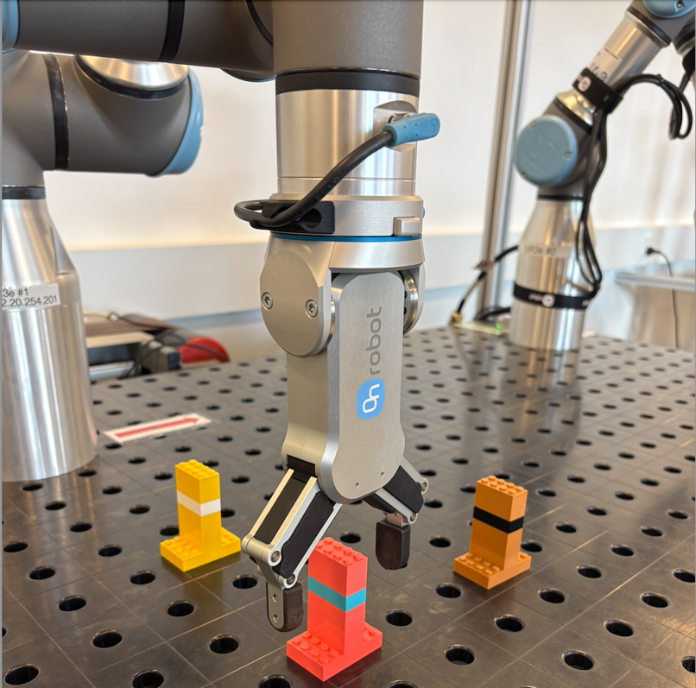
Vær opmærksom på at hvis man laver ’freehand’, så skal vi vælge ”base” for at aflæse koordinater.
Vi skal huske når vi hard-coder, at vi skal prøve an angive baner i decimaler som kan deles med 25, da det er indstillingerne fra robotternes side i lokalet.
Det er også en god ide at bede C# om at sende koordinaterne til terminalen, da vi så kan validere om disse fungerer.

